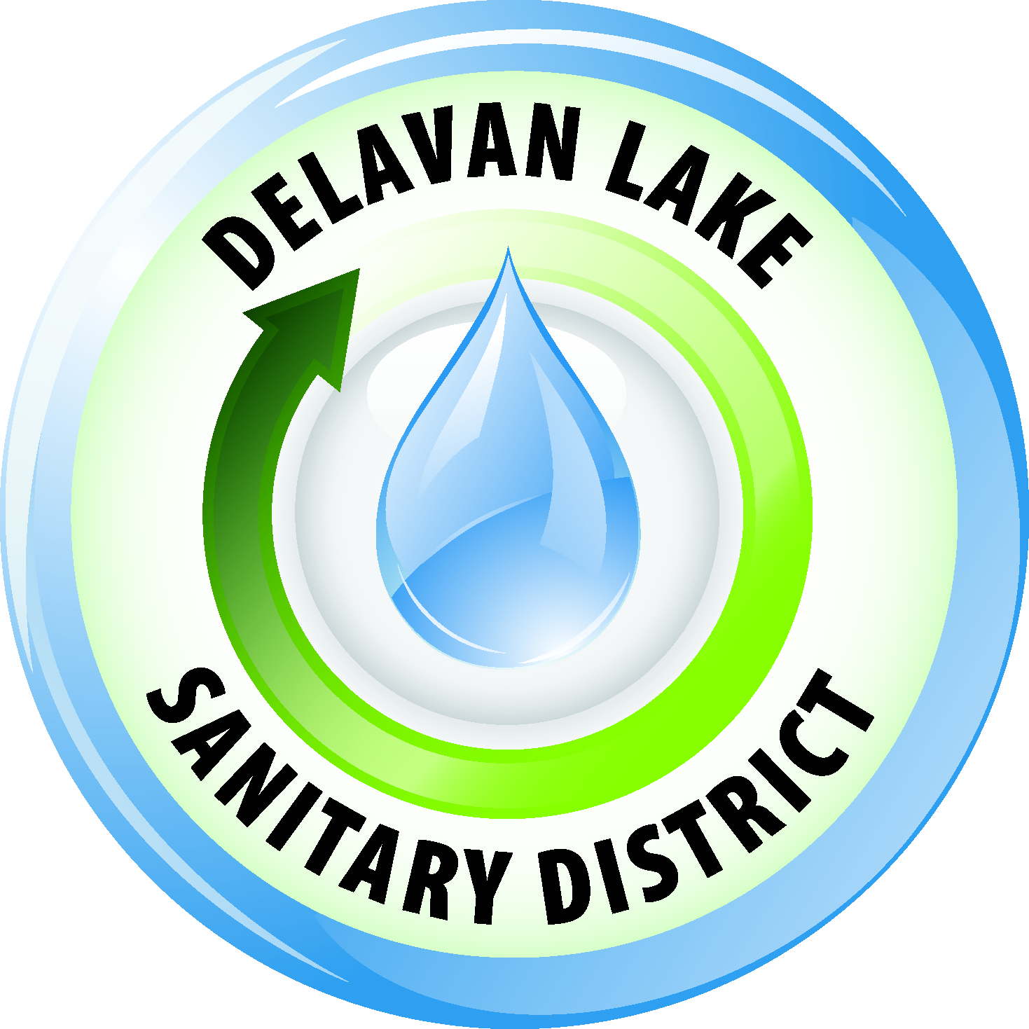
Delavan Lake Sanitary District
of the Towns of Delavan and Walworth

Tom Miller, President Richard Beers, Commissioner
Kim O’Keefe, Secretary David Reider, Commissioner Tom Johnson, Commissioner James DeLuca, Administrator

Official Notice

The Delavan Lake Sanitary District Commission will hold the Regular & Closed Session December Commission meeting on Wednesday, December 13th, 2017, at 9:00 A.M. in the Meeting Room at the District Headquarters located at 2990 County Road “F” South, Delavan, Wisconsin.

The commissioners upon motion duly made and carried will convene to closed session. The purpose of the first closed session is to deliberate or negotiate the purchasing of public properties, the investing of public funds, or conducting other specified public business, whenever competitive or bargaining reasons require a closed session pursuant to section 19.85(1)(e), Wisconsin Statutes. Specifically to be discussed land purchases in the Town of Delavan.

The purpose of the second closed session is to consider employment, promotion, compensation or performance evaluation data of any public employee over which the governmental body has jurisdiction or exercises responsibility pursuant to section 19.85(1)(c), Wisconsin Statutes. Specifically to be discussed is the performance and duties of the Secretary/receptionist.

After the regular meeting has been properly convened, the President of the Commission will announce to all those present the purpose of the Closed Session and the fact that the Commission intends to convene in Closed Session for the above-delineated purposes. Following the announcement, upon motion duly made and seconded and acted upon by the majority of the Commissioners present as required under section 19.85(1)(a), Wisconsin Statutes, the Closed Session will take place which will be attended by the Commissioners and required staff.

You are further notified that the Commission reserves the right to adjourn the meeting while still in Closed Session, or the Commission may reconvene into Open Session pursuant to section 19.85(2), Wisconsin Statutes, for possible additional discussion and action concerning any matter discussed in Closed Session, for continuation of the Commission meeting or to conclude the Commission meeting.

Agenda

- Call to order
- Roll Call
- Declaration of a quorum present for doing business
- Approval of minutes of Regular Meeting of November 14, 2017
- Comments and suggestions of citizens present regarding agenda items
- Financial
  - Review bills for payment – Check numbers 25621 through 25664
  - Acceptance of Allocation of Funds through November 30, 2017
  - Financial Statements for periods ending November 30, 2017
- Administrator’s Monthly Report
- Lake Committee Report
- Discussion/possible action regarding damage claim at 319 Eagle Street
- Discussion/possible action regarding payment recommendation for Wolf Paving Co. Inc.
- Discussion/possible action regarding KMLT Membership
- Discussion/possible action regarding DLIA membership
- Discussion/possible action regarding 2018 weed harvesting concerns – offloading sites
- The commissioners upon motion duly made and carried will immediately convene to closed session. The purpose of the closed session is to deliberate or negotiate the purchasing of public properties, the investing of public funds, or conducting other specified public business, whenever competitive or bargaining reasons require a closed session pursuant to section 19.85(1)(e), Wisconsin Statutes. Specifically to be discussed land purchases in the Town of Delavan.
- The commissioners upon motion duly made and carried will immediately convene to closed session. The purpose of the second closed session is to consider employment, promotion, compensation or performance evaluation data of any public employee over which the governmental body has jurisdiction or exercises responsibility pursuant to section 19.85(1)(c), Wisconsin Statutes. Specifically to be discussed is the performance and duties of the Secretary/receptionist.
- Reconvene in open session
- Discussion/possible action on any closed session matters.
- Discussion/possible action or confirmation of next meeting date
- Comments and suggestions of citizens present
- Future agenda items
- The commissioners will recess for an employee appreciation luncheon at the Village Supper Club
- Adjournment

Please take further notice that the Commissioners will remain to attend the staff holiday luncheon. This will be strictly a social function and no District business shall be conducted.

Posted December 8, 2017

Any person who has a qualifying disability as defined by the Americans with Disabilities Act that requires the meeting or materials to be in an accessible location or format must contact the Delavan Lake Sanitary District, 2990 South County Road F, Delavan, Wisconsin at least twenty-four (24) hours prior to the commencement of the meeting so that necessary arrangements can be made to accommodate the request.

The Delavan Lake Sanitary District is an Equal Opportunity Employer

