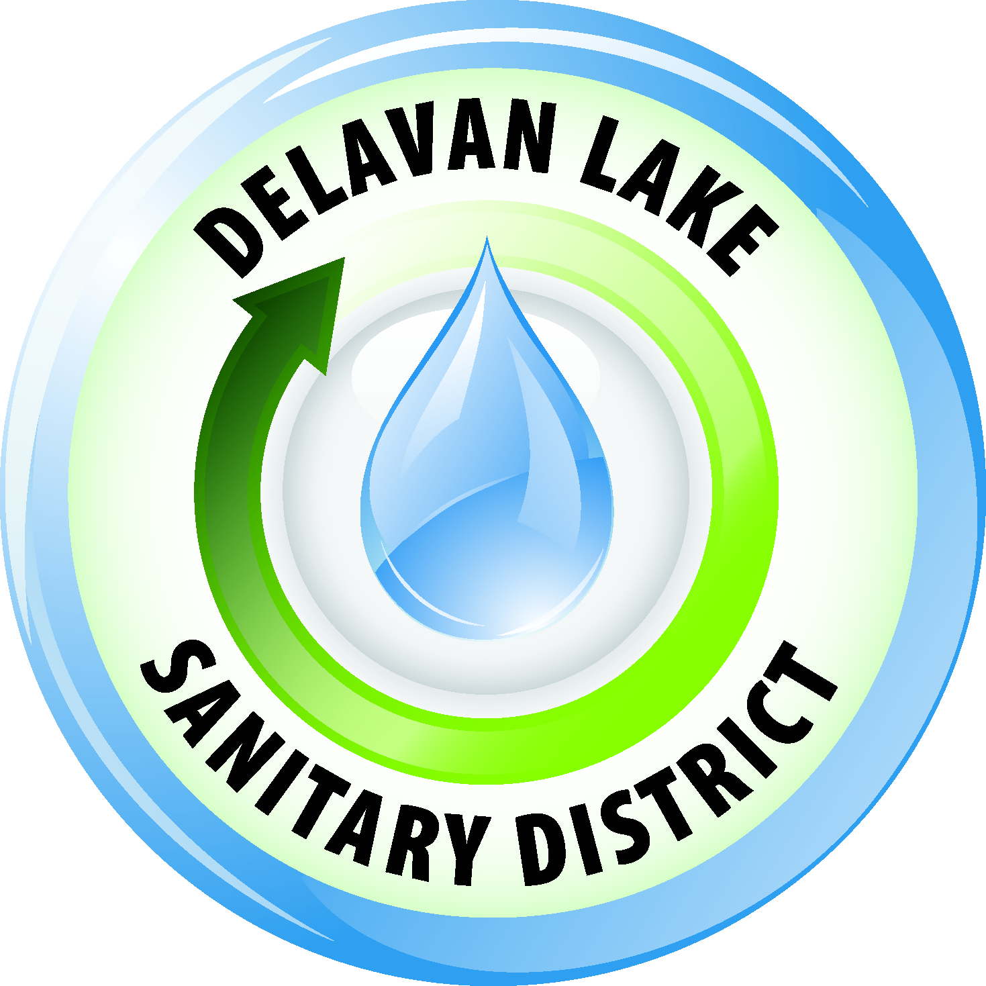
Delavan Lake Sanitary District
of the Towns of Delavan and Walworth

Tom Miller, President Richard Beers, Commissioner
Kim O’Keefe, Secretary David Reider, Commissioner
Tom Johnson, Commissioner James DeLuca, Administrator

OFFICIAL NOTICE

Healthy Lakes Initiative Information Meeting

Please note that a quorum of the Delavan Lake Sanitary District Commission may be attending a Healthy Lakes Initiative Informational Meeting on Saturday, June 2, 2018 from 10:00 A.M. to 12:00 P.M. in the Meeting Room at the Delavan Sanitary District located at 2990 County Road F South, Delavan, Wisconsin.

Posted May 24, 2018

Notice is hereby given that a majority of the Commission members may be present at the above-scheduled meeting to gather information over which they have decision making authority. This constitutes a meeting of the Commission pursuant to Badke v. Greendale Village Board, 173 Wis. 2d 553 (1993) and must be noticed, although the Commission will take no action at this meeting

Any person who has a qualifying disability as defined by the Americans with Disabilities Act that requires the meeting or materials to be in an accessible location or format must contact the Delavan Lake Sanitary District, 2990 South County Road F, Delavan, Wisconsin at least twenty-four (24) hours prior to the commencement of the meeting so that necessary arrangements can be made to accommodate the request.

The Delavan Lake Sanitary District is an Equal Opportunity Employer

