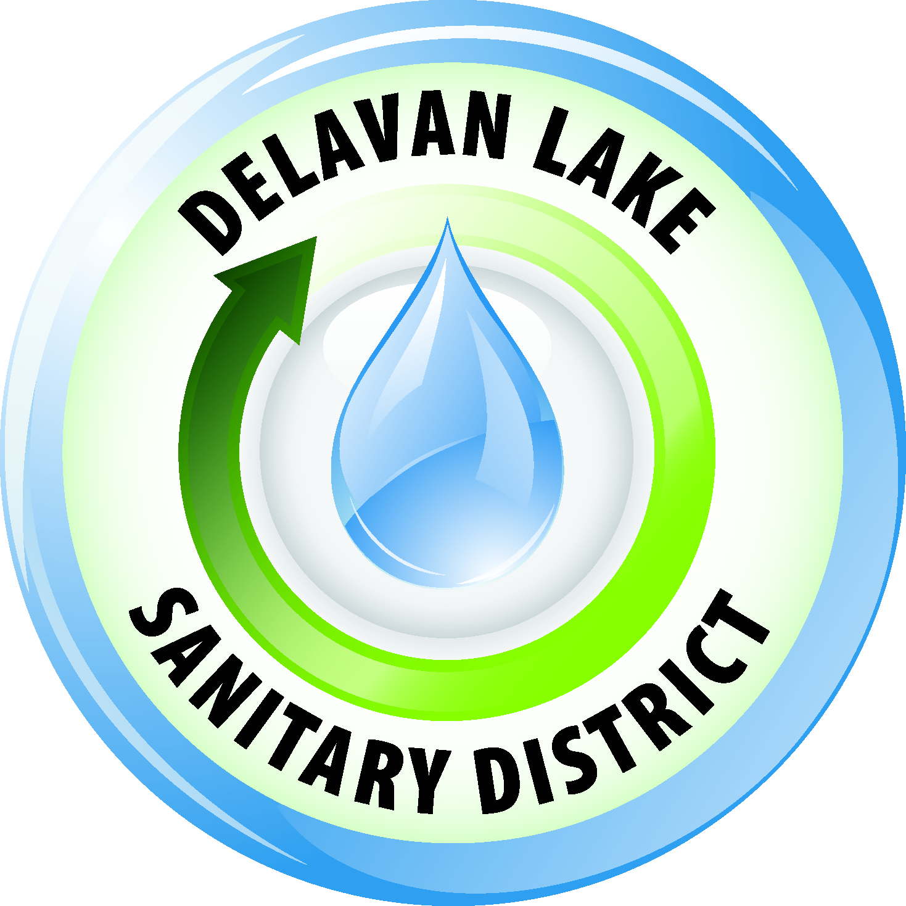
Delavan Lake Sanitary District
of the Towns of Delavan and Walworth

Tom Miller, President Richard Beers, Commissioner
Kim O’Keefe, Secretary David Reider, Commissioner
Tom Johnson, Commissioner James DeLuca, Administrator

Official Notice

The Delavan Lake Sanitary District Commission will hold a Special USGS Meeting to discuss lake monitoring on Wednesday, May 2, 2018, at 2:00 P.M. in the Meeting Room at the District Headquarters located at 2990 County Road “F” South, Delavan, Wisconsin.

Agenda

- Call to order
- Roll Call
- Declaration of a quorum present for doing business
- Comments and suggestions of citizens present regarding agenda items
- Discussion/possible action regarding lake monitoring/testing
- Comments and suggestions of citizens present
- Adjournment

Posted April 26, 2018

Any person who has a qualifying disability as defined by the Americans with Disabilities Act that requires the meeting or materials to be in an accessible location or format must contact the Delavan Lake Sanitary District, 2990 South County Road F, Delavan, Wisconsin at least twenty-four (24) hours prior to the commencement of the meeting so that necessary arrangements can be made to accommodate the request.

The Delavan Lake Sanitary District is an Equal Opportunity Employer

