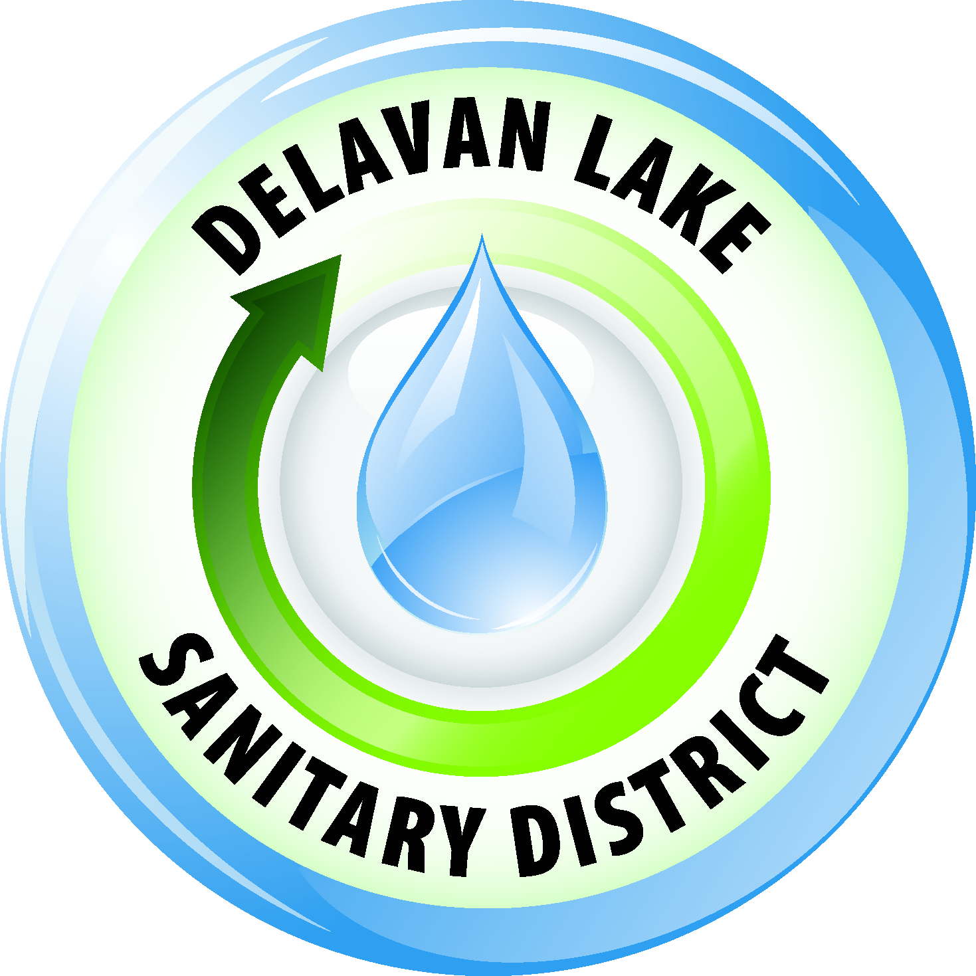
Delavan Lake Sanitary District
of the Towns of Delavan and Walworth

Tom Miller, President Richard Beers, Commissioner
Kim O’Keefe, Secretary David Reider, Commissioner
Tom Johnson, Commissioner James DeLuca, Administrator

Official Notice

The Delavan Lake Sanitary District Commission will hold a Special & Closed Session Commission meeting on Tuesday, September 25th, 2018, at 9:00 A.M. in the Meeting Room at the District Headquarters located at 2990 County Road “F” South, Delavan, Wisconsin.

The purpose of the closed portion of the meeting is to consider employment, promotion, compensation or performance evaluation data of any public employee over which the governmental body has jurisdiction or exercises responsibility as authorized under Section 19.85(1)(c), Wisconsin Statutes. Specifically to be discussed is the performance and compensation of staff.

After the regular meeting has been properly convened, the President of the Commission will announce to all those present the purpose of the Closed Session and the fact that the Commission intends to convene in Closed Session for the above-delineated purposes. Following the announcement, upon motion duly made and seconded and acted upon by the majority of the Commissioners present as required under section 19.85(1)(a), Wisconsin Statutes, the Closed Session will take place which will be attended by the Commissioners and required staff.

You are further notified that the Commission reserves the right to adjourn the meeting while still in Closed Session, or the Commission may reconvene into Open Session pursuant to section 19.85(2), Wisconsin Statutes, for possible additional discussion and action concerning any matter discussed in Closed Session, for continuation of the Commission meeting or to conclude the Commission meeting.

Agenda
- Call to order
- Roll Call
- Declaration of a quorum present for doing business
- The commissioners upon motion duly made and carried will immediately convene to closed session. The purpose of the closed session is to consider employment, promotion, compensation or performance evaluation data of any public employee over which the governmental body has jurisdiction or exercises responsibility pursuant to section 19.85(1)(c), Wisconsin Statutes. Specifically to be discussed is the performance and compensation of field and office staff.
- Reconvene in open session
- Discussion/possible action on any closed session matters
- Discussion/possible action final 2019 budget
- Discussion/possible action setting Public Hearing Date
- Adjournment

Posted September 21, 2018

Any person who has a qualifying disability as defined by the Americans with Disabilities Act that requires the meeting or materials to be in an accessible location or format must contact the Delavan Lake Sanitary District, 2990 South County Road F, Delavan, Wisconsin at least twenty-four (24) hours prior to the commencement of the meeting so that necessary arrangements can be made to accommodate the request.

The Delavan Lake Sanitary District is an Equal Opportunity Employer

